Sanjeev Maharjan - KCAC10

Kathmandu Contemporary Arts Centre is proud to present the work of Sanjeev Maharjan. The works in this exhibition were made as a KCAC artist-in-residence and represent an intense six months of work at the Centre.

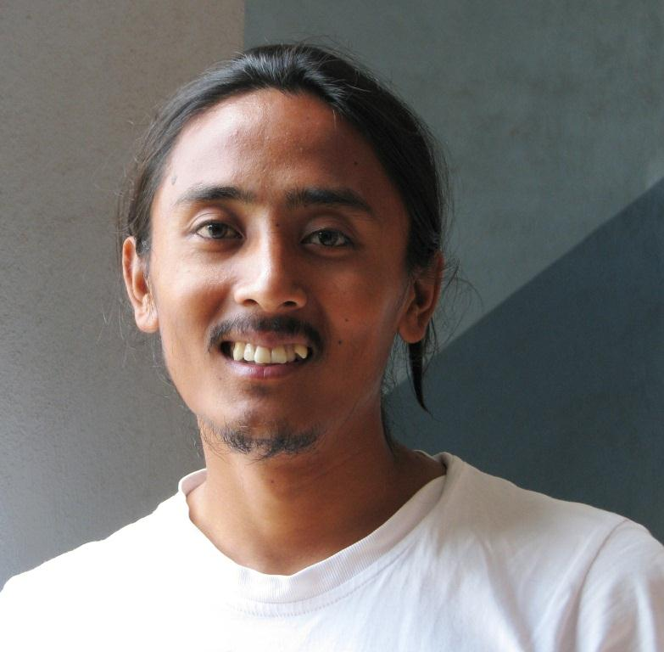

Repeating Bodies
In this series, I have painted the bodies of pigs, as I have experienced them—how I have seen them. I have grown up encountering their carcasses. I carry the image of their dead bodies with me every day.

The place where I live, Khichapokhari, is lined with meat shops. They sell the meat of fish, goats, chickens, buffaloes and pigs. Every morning, I see a rickshaw man carrying the dead bodies of pigs and transporting them to the shops. The white and light pink tones of the skin gradually turn red as the blood splatters over the dead bodies.
When they arrive at the shops they are cut into pieces. The forms of the bodies are gradually deformed, losing their identity as they are cut into different shapes and sizes. These pieces of flesh and meat are exhibited in front of the shops like show pieces. The heads displayed on one side, legs on the other, and so on with each part of the body. The memory of the whole, live creature is transformed. At last, nothing remains from the body. It exists at morning and vanishes by evening. And this repeats everyday.

These images are always with me. I want people to wake up and notice things that they would normally pass by without thinking. I see my work as a tool to invite people to see these visceral images through my eyes.

